MODULE 5 QUES 4
https://www.hackerearth.com/practice/basic-programming/input-output/basics-of-input-output/practice-problems/algorithm/count-divisors/
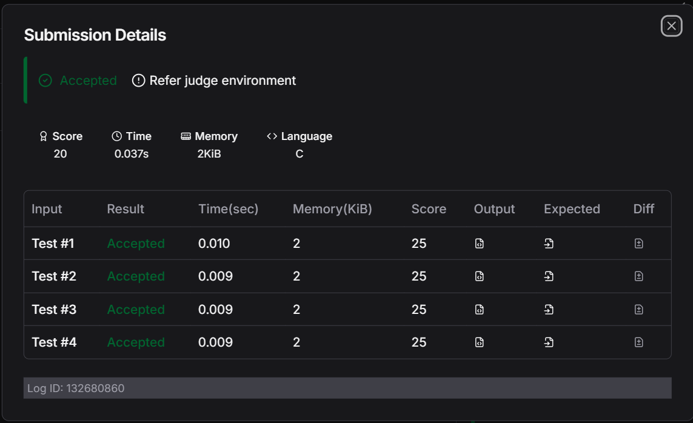
CODE
#include <stdio.h>

int main() {
int l, r, k;

// Read the three space-separated integers from the input
if (scanf("%d %d %d", &l, &r, &k) == 3) {

// Compute the count in O(1) time complexity
int count = (r / k) - ((l - 1) / k);

// Print the final result followed by a newline
printf("%d\n", count);
}

return 0;
}

